
Teacher of Science
Information Pack

Dear Candidate,

Thank you for taking the time to consider joining the talented staff team here at Redden Court School and The Success for All Educational Trust. I am very proud to be the Headteacher of Redden Court and the Executive Headteacher of a Trust that is committed to the success of all students in our care.

Notable Achievements in recent years:

- We have recently been re-accredited as a Thinking School by the CEDU at the University of Exeter
- In 2019 we were awarded the ‘Quality in Careers’ standard for our work in this area
- The school received 2 awards from SSAT for the Progress and Attainment of students in 2016 and 2 awards in the same categories for 2017
- In the Havering Learning Partnership Awards 2019 we received the award for Wellbeing and in 2018 we received awards for Best Progress in the “Open” Subjects and an Enrichment Award for Most Innovative Technology Project. In 2017 we received awards for Best Progress Overall, Best Progress Made by Disadvantaged Students, Best Progress Made by More Able Students, Best Progress for “Open” Subjects, Best Progress in Mathematics, Best Progress in Humanities, Most Improved Attainment in the EBacc 2016
- In 2016, Ofsted recognised the progress made by the school and the fact that we have created an inclusive community where we focus on working with families to raise aspirations

We pride ourselves on being a fully comprehensive school placed at the heart of the community. We want all of our students to be happy, ambitious and to achieve results that reflect their true potential.

Our school has served the local community of Harold Wood for many years, providing a high quality education to the students of this area.

Our vision is focused on a ‘Commitment to Success for All’ and high levels of aspiration for every member of our community. The school is forward thinking and progressive. We seek to achieve the very best for all of our students through the use of a rich variety of educational approaches. We have caring staff who are dedicated to ensuring the students are successful in every aspect of their learning.

Redden Court is the lead school in the Success for All Educational Trust and is recognised as one of the highest performing mixed comprehensive schools in Havering. The MAT will expand over the next few years to incorporate both local Secondary and Primary Schools and currently includes 3 Secondary Schools.

We are an accredited ‘Thinking School’ and have very close links with the Cognitive Education Development Unit at the University of Exeter. Metacognition and the development of thinking skills is at the heart of our teaching and learning in the school as we believe it plays an important part in developing resilient and independent learners.

We also have very strong links with the Havering Teacher Training Programme, we are a senior partner in the Empower Teaching Alliance and we are recognised as a Leading Edge School by the SSAT. The school has also been accredited with Investors in People (Silver), Healthy Schools (Gold), The International School Award, The Safeguarding Standard, Gold Travel Ambassadors Award and is a Fairtrade School.

We are a growing community Trust with inclusion at the heart of our ethos and require leaders who will bring this vision to life.

These are exciting times for Redden Court School with so much change and challenge in the future.

Perceptions play a major part in your decision when choosing the right school for you to lead and build a successful career. We strongly urge you to come and visit the school prior to application.


Mr Paul Ward
Redden Court School
Executive Headteacher for The Success for All Educational Trust

Teacher of Science
Start: September 2020
Salary: Teacher Mainscale Outer London

Redden Court School, a place where “Pupils are enthusiastic about
coming to school to learn.” (OFSTED SEPTEMBER 2016)

Would you like to move your career forward in a friendly environment with eager students and support from an experienced faculty, in one of the highest performing schools in our Local Authority? We are oversubscribed, serve Harold Wood well and we are only twenty minutes from the heart of London.

Our staff turnover is low because teachers come to us and realise our grass is indeed greener. We invest in our staff to help them to become the best possible teachers they can be. There are excellent opportunities for people who work hard. Effort is often recognised in career development. Many who came to us as NQTs now have substantial leadership roles. Our CPD programme and collegiate approach are highly effective. Staff morale is high and so is that of our students and their community.

Our school mantra is "Committed to Success for All." That includes our staff and we want the very best for our students. OFSTED recently said we “have created an inclusive community where pupils and staff relate well to each other. The school is focused on working with families to raise aspirations for pupils.”

If you are an inspiring, enthusiastic teacher of Science who recognises that the best practitioners always want to improve, we would like to talk to you. This is an exciting opportunity to be part of a forward thinking school. Applications from NQTs would be particularly welcome and we will also consider job-sharing if that means we get the right people.

If you would like to speak to the Head Teacher, Mr P Ward, please feel free to telephone the school. We welcome visits to the school from potential applicants.

We are committed to safeguarding and promoting the welfare of children and young people and we expect all staff to do likewise.

For details on how to apply, please visit our website: https://www.reddencourtcloud.co.uk/about-us/vacancies

Closing date: Thursday, 5th March 2020 at 12pm. Interviews will take place on Tuesday, 10th March 2020

Redden Court School is the lead school in the Success for All Educational Trust.
Cotswold Road, Harold Wood, Romford, Essex, RM3 0TS.
Tel: 01708 342293

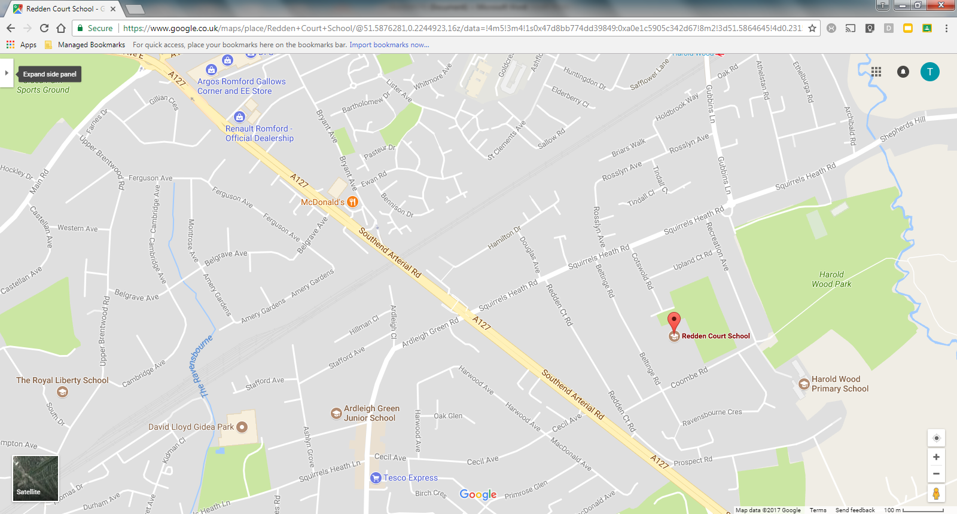

Job Profile

Teacher of Science

Pay scale: Main scale
Reports to: Head of Science Faculty

Principal duties and responsibilities

1. To strive for excellence in teaching and learning in the classroom.

2. To ensure that agreed school and faculty policies are adhered to in all
teaching and administrative activities.

3. To liaise with parents / carers on student progress and attend consultation
evenings / progress review days as specified in the school calendar.

4. To assess and report on students at all levels, including those with special
educational needs and disabilities.

5. To ensure that there is a sharing of information regarding the progress of individual students with relevant Tutors, Pastoral Heads and the SENCO.

6. To lead the development of the subject through attendance and
discussions at regular calendared faculty meetings.

7. To lead curriculum planning in order to ensure that the curriculum on offer to students is appropriate to the needs of all and ensures equal access.

8. To lead enrichment activities for students as directed by Head of Faculty.

9. To be responsible for Key Stage 3 and Key Stage 4 groups and their progress against school targets.

10. To participate in relevant staff development programmes within the school.

11. To participate in the pastoral care structure of the school as a Form Tutor or member of the support team.

12. To undertake any reasonable duties at the direction of the Head Teacher which are appropriate to the needs of the school.

Caroline Morris
PA to Head Teacher
Paul Ward
Head Teacher
Sue Thompson
SLT Link for Science

Megan Slattery
Lead Practitioner (internal)

Joanne Lebow
Teacher of Science

Kevin Hikel
Teacher of Science

Nikki Brotherton
Teacher of Science

Roger Ruthven
Teacher of Science

Sarah Harvey
2nd in Science Faculty
Sarah Kruse
Teacher of Science
Kelly Davies
Head of Science Faculty

Google Education

Google Education is an exciting and innovative way of learning, introducing easy tools to engage students whenever, wherever on any device!

In summer 2012, Redden Court School adopted G Suite for Education, the free web-based communication and collaboration suite available to education establishments.

With products including Gmail, Google Calendar, Google Drive, Google Sites and Google Classroom, Redden Court School recognised the potential it would bring to classroom learning, knowledge sharing across the academies, improvements in administrative efficiency and providing access from home for all.

This enables all our students and staff to have access to the most up-to–date technology. Our academies have also rolled out many class sets of Google Chromebooks, affordable browser-based laptops that provide quick, simple access to the web!



Professional Learning Programme 2019-20
Compulsory CPD - we will run a number of training sessions which are compulsory for identified staff, these will include Child Protection/Safeguarding and whole school Teaching and Learning priorities.
Staff Development Days - 2 staff development days are planned and on the calendar below (SDD1: 3/9/19 and SDD2: 6/1/20). The remaining 3 days are disaggregated, when staff do not have to be on site. The hours staff need to complete for these 3 days are to be divided in the following ways: (please note these are all compulsory sessions)
- Focus Group Meetings (5 hours)
- Action Research (3 hours)
- TLC's (5 hours)
- Faculty Training Time (5 hours) (HOFs to plan and forward to TG)
Directed Time - in addition to the training stated above, staff are expected to attend an additional 5 hours of directed time CPD - these should be chosen in advance with you line manager and relate to your Appraisal Targets. Please forward all choices to TG by 30/09/19 so staff running these sessions know numbers.
Compulsory CPD – these sessions are compulsory for staff. If for any reason you cannot attend, you will have to complete the session at another time.
SDD – Staff Development Days; there are 5 of these and they are compulsory for ALL staff.
Focus Groups - these are directed time and therefore compulsory training sessions for staff. There should be at least one representative from each Faulty where possible, on each focus groups. (5 hours)
TLCs – these sessions are compulsory training workshops for all Teachers.
Directed Time – Staff need to choose a minimum of 5 sessions as directed time.
NQT Training – these sessions are run by the Empower Teaching Alliance and are compulsory for NQTs (this therefore counts as their directed time). The first and last sessions are compulsory, then NQT’s choose 6 of the remaining to attend.
Governors/Trustees – these sessions are for members of the Governing Body and Trustees. These will commence at 5.30pm (unless otherwise stated).
Associate staff should also complete 18 hours of training; this could be a mixture of compulsory sessions, directed time sessions or individual identified training, as appropriate. Associate staff will also be required to complete a proforma as evidence of this.
Staff who work part time should attend the appropriate number of pro rata sessions.
All training commences at 3.20pm unless otherwise stated.
Date | Event | Staff | Location | Themes | SDP
03/09/19 | SDD1  (All day) | All  HOYS and Tutors  HOFs  Associate LFs | New Hall  Various  Various  Various | Welcome, results, priorities for 2019/20 (PW)  Results (ST)  T&L Key Messages (SC)  CPD/Appraisal (TG)  Pastoral Update (WK)  Prevent (External)  New Year 7 & SEND students (MG, JL)  Department / Faculty Time  Pastoral Team Meetings & HOF Meeting  Associate Staff Team Meetings  Teaching and Learning Expectations (FG)
04/09/19 | Compulsory Training | TBC | TBC | Epipen, Buccal and Epilepsy (AB)  This session will show all staff how to administer an epipen and buccal medication. It will also raise staff awareness on what to do in the event of an epileptic fit.
04/09/19 | Compulsory Training - New Staff Induction | New Staff who could not attend on 28/06/19 | G22 | - Professional Practice (PW)  - Safeguarding (WK)  - Health and Safety (BT, TD)  - School Procedures and Key Policies (TG)  -Teaching, Learning and Assessment (FG)  - IT Systems (SC)
04/09/19 | Compulsory Training | All | New Hall | - ARP Prospectus (HA)  - Disadvantaged Students (JB)
TBC | Additional Training (16.15-17.30) | NQTs  Compulsory | Hall Mead School | Introductory Meeting  This meeting will provide an overview of what challenges an NQT may face during their induction year, explore NQTs’ anxieties and provide strategies for avoiding classic NQT pitfalls, provide NQTs with an opportunity to network and provide feedback as to what they feel their training needs are. Training requests will inform the planning of the NQT programme.
09/09/19  (Briefing) | Compulsory Training | All | New Hall | Child Protection Update (WK)
12/09/19 | Compulsory Training | All | New Hall | Child Criminal Exploitation (WK)
16/09/19 | Compulsory Training | SLT&HOYs | New Hall | Positive Handling Training
16/10/19 | Directed Time | Teachers | TBC | Staff Literacy 1: Spelling
19/09/19 | Compulsory Training | Teachers | New Hall | Thinking Skills (EB)
23/09/19 | Governor/  Trustee Briefing | Governing Body and Trustees | F57 | 2019 Results (ST)
25/09/19 | Compulsory Training  (1 hour) | New Team Leaders | TBC | Appraisal: documentation and target setting (TG, PW, ST).
TBC | NQT Training | NQTs | Hall Mead School | Pastoral/Discipline – Managing behaviour is a challenge for all teachers at all stages. This session looks at one approach to behaviour: disipline with dignity and seek, through case studies and examples, to support new teachers in developing their confidence,skills and repertoire when dealing with challenging behaviour in schools.
30/09/19  (Briefing) | Compulsory Training | Teachers | New Hall | New Ofsted Framework (FG)
2/10/19 | Directed Time | Teachers | TBC | Google/RCS Technology (SC)
03/10/19 | Compulsory Training  (1 hour) | Teachers | New Hall | Action Research (RR)
8/10/19 | Directed Time | Teachers | TBC | New HOF/Subject Leader Training (LM)
9/10/19 | Directed Time | Teachers | TBC | Literacy across the Curriculum (KN) Practical ways to embed literacy tasks into every subject.
TBC | NQT Training | NQTs | Hall Mead School | Ensuring homework helps - setting appropriate, rigorous homework is always a challenge. This session will look at why we set homework, the value of homework and how homework is a valuable tool for lessons.
16/10/19 | TLC 1/5 | Teachers | Various
17/10/19 | Directed Time | Teachers | TBC | Marking
TBC | NQT Training | NQTs | Hall Mead School | Assessment: this session will explore the different forms of assessment in secondary schools and give participants the opportunity to share good practice or get new ideas. We will look at assessment from the point of view of pupil, teacher, school leader, parent and inspector in order to understand how we balance the conflicting demands that exist within school based assessment. Prior to this session, participants will need to make sure they have a working knowledge of their own school's procedures.
21/10/19 | 25/10/19 | HALF TERM
TBC | NQT Training | NQTs | Hall Mead School | Managing Workload - Teaching has a heavy workload; that won’t go away anytime soon and shifts and changes as promotion brings more time but heavier demands. Using the research and publication of Brian Tracy, this session will look at some practical steps and decisions that we can take to help manage and, in some cases, reduce our workload.
30/10/19 | Directed Time | Teachers | TBC | Numeracy across the Curriculum (CS) Delivering mathematical skills in every subject in a consistent manner (NT)
04/11/19 | Governor/  Trustee Briefing | Governing Body and Trustees | F57 | Governor and Trustee Briefing:  – TBC
6/11/19 | Directed Time | Teachers | TBC | The role of the Form Tutor (WK)
7/11/19 | Compulsory Training  (1 hour) | Teachers | New Hall | SEND/Differentiation (MG)
TBC | NQT Training | NQTs | Hall Mead School | Moving on from teaching to the middle - Stretch and Challenge: NQT's will leave this session with practical ideas and resources to implement effective stretch and challenge in their classroom. This session will also provide you with an opportunity to consider the needs of pupils that are more able as well as some of the barriers these pupils face in the classroom. Building in stretch and challenge should not and does not need to add to teacher workload; rather we can use a range of simple resources from our 'Teacher Toolkit', including questioning, challenge questions, feedback and homework projects.
12/11/19 | Directed Time | Teachers | TBC | Staff Literacy 2: Punctuation
14/11/19  (07.45-08.30) | Focus Groups 1/5 | Focus Groups Members | Various | Disadvantaged (JB)  High Prior Attainers (MG)  SEND (HA)
20/11/19 | Directed Time | Teachers | TBC | Effective use of SDA's in Lessons (MG)
5/12/19 | Compulsory Training | All Staff | TBC | Memory and Retention of Information Techniques
12/12/19 | TLC 2/5 | Teachers | Various
TBC | TBC | NQTs | Redden Court School | Diminishing the Difference - This session will be focused on the key group of pupils whose economic disadvantage can mean that they do less well than their peers. This session, led by an experienced champion of pupils in receipt of the Pupil Premium will outline some of the challenges that these pupils face and how we might work to overcome them.
19/12/19 | Compulsory | All Staff | Online | Online Health and Safety & Fire Safety training - to be completed by 19/12/19 and certificates emailed to TG as evidence | P8
20/12/19 | 03/01/20 | CHRISTMAS HOLIDAYS
06/01/20 | SDD2  (All day) | Teachers and Royal Liberty Teachers | New Hall | Teaching and Learning Conference
 |  | LFs and Royal Liberty TA’s | TBC | TBC
 |  | Associate Staff | TBC | TBC by BT
9/1/20 | Directed Time | Teachers | TBC | Developing Resilience and Independence in Students (CP)
TBC | NQT Training | NQTs | Hall Mead School | Lessons Within lessons: Everyday Differentiation and Planning -This session will focus on sharing and developing effective differentiation strategies for use in the classroom and an introduction to the 'lesson within lesson' approach to teaching to help make differentiation an extension of your natural everyday practice, rather than a bolt-on activity. We'll also discuss different lesson planning strategies and the backward design approach to long-term planning to help better manage planning requirements.
TBC | NQT Training | NQTs | Hall Mead School | Numeracy Matters - the development of numeracy is a functional skill we would wish all our pupils to have but it isn't just the realm of the maths teachers! This session explores ways to help students develop numeracy across all subjects and will leave you with the confidence and practical skills to support numeracy in your own subjects.
15/1/20 | Directed Time | Teachers | TBC | Group Work and Debates (BF&NB)
22/1/20 | Directed Time | Teachers | TBC | Health Eating - a whole school approach (GG)
23/1/20 | Directed Time | Teachers | TBC | Curriculum Planning
30/01/20  (07.45-08.30) | Focus Groups 1/5 | Focus Groups Members | Various | Disadvantaged (JB)  High Prior Attainers (MG)  SEND (HA)
03/02/20 | Governor/  Trustee Briefing | Governing Body and Trustees | F57 | Governor and Trustee Briefing:  – TBC
6/2/20 | TLC 3/5 | Teachers | Various
TBC | NQT Training | NQTs | Hall Mead School | Making Marking Meaningful -This session will focus on how teachers can mark with maximum impact, in line with own school policy. Evidence from the Education Endowment Fund suggests that high quality effective marking over time is one of the most effective ways of improving learning. OFSTED inspectors increasingly look for quality and impact of marking when judging the overall quality of learning in a school. We will consider ways to maximise the impact of our marking, so it enables all pupils to show progress whilst minimising the burden on teachers. We will look at how to build marking into Schemes of Learning to ensure consistency and how to plan in parallel with set data drop deadlines to avoid duplication and wasted effort.
12/2/20 | Directed Time | All | TBC | Difficult Conversations (PW)
14/2/20 | Directed Time | Associate Staff | Online (4 hours) | Role of Mid Day Assistants to be completed by 14/02/20 and certificates emailed to TG as evidence
17/02/20 | 21/02/20 | HALF TERM
TBC | NQT Training | NQTs | Bower Park Academy | Linking Literacy and Oracy in the Classroom - our 21st century students are now entering a world where they will be expected to read and write more than at any other point in human history. This session will aim to help NQTs from all curriculum areas to develop an understanding of the fundemantal link between literacy and oracy and how addressing this link will improve outcomes for all students.
26/2/20 | Directed Time | Teachers | TBC | How teachers explain/model new ideas and information (LM/NT)
TBC | NQT Training | NQTs | Frances Bardsley Academy | Improving the impact of questioning - Questioning is a key and essential element for all teachers toolkits. This session will build on your questioning knowledge and focus on how to evolve your practice and develop your skills. We will look at how to question students to achieve the best from them and also new initiatives to develop a strong and personal questioning style. There will be time to discuss how to question students and how this will show progress both within lessons and within your skill set.
4/3/20 | Directed Time | Teachers | TBC | Staff Literacy 3: Grammar
11/3/20 | Directed Time | Teachers | TBC | Tracking Progress
19/03/20  (07.45-08.30) | Focus Groups 3/5 | Focus Groups Members | Various | Disadvantaged (JB)  High Prior Attainers (MG)  SEND (HA)
TBC | NQT Training | NQTs | Frances Bardsley Academy | Leading Learning  This session will aim to help NQTs move their classroom practice to consistently good and outstanding. NQTs will gain an understanding of what good and outstanding progress looks like in a lesson and how to ensure that this becomes a regular part of all of their lessons. Attendees will leave the session with practical, subject specific strategies to improve their practice.
2/4/20 | TLC 4/5 | Teachers | Various
TBC | NQT Training | NQTs | Hall Mead School | Twitter, Technology and Trying New Ideas’: Technology surrounds the world in which we live and the pupils we teach. It filters into our schools and classrooms as computers, laptops and interactive white boards, yet we don’t always know what to do with them. This session aims to share ideas for using technology in lessons to improve teaching and increase engagement, as well as looking at how social media can support you as a teacher. Ideas will also be shared on activities and teaching methods that can motivate pupils to get involved and offer interactive activities that you can try or adapt, or even inspire you to come up with your own!
06/04/20 | 17/04/20 | EASTER HOLIDAYS
23/04/20 | Directed Time | Teachers | TBC | Staff Wellbeing (HW)
TBC | NQT Training | NQTs | Hall Mead School | The Science of Memory- This session draws on the key messages around knowledge recall, cognitive load and low stakes testing to boost retention and recall, which we all know is vital for our new GCSE courses.
04/05/20 | Governor/  Trustee Briefing | Governing Body and Trustees | F57 | Governor and Trustee Briefing:  – TBC
07/05/20  (07.45-08.30) | Focus Groups 4/5 | Focus Groups Members | Various | Disadvantaged (JB)  High Prior Attainers (MG)  SEND (HA)
21/5/20 | TLC 5/5 | Teachers | Various
25/05/20 | 29/05/20 | HALF-TERM
TBC | NQT Training | NQTs | Empower Teaching Alliance | Collaborative Working - this session focuses on the purpose of group learning and offers suggestions, advice and resources to all for healthy functioning collaborative learning.
19/06/20 | Compulsory Training | SLT | St Francis Hospice | TBC
29/06/20 | Governor/  Trustee Briefing | Governing Body and Trustees | F57 | Governor and Trustee Briefing:  – TBC
02/07/20  (07.45-08.30) | Focus Groups 5/5 | Focus Groups Members | Various | Disadvantaged (JB)  High Prior Attainers (MG)  SEND (HA)
TBC | NQT Training | NQTs  Compulsory | Hall Mead School | Career Paths in Teaching / Moving into life as an RQT -This final session will focus on evaluating your induction year, on opportunities for your continuing professional development and on celebrating achievements. There will also be time to speak individually about any issues or ask any final questions you may have.
10/07/20 | Compulsory Training | Teachers | New Hall | All Action Research Presentations to be completed by 10/07/19
20/07/20 | SDD3  (All day) | All Staff
21/07/20 | SDD4  (All day) | All Staff
22/07/20 | SDD5  (All day) | All Staff

EXTRA-CURRICULAR CLUB – SPRING TERM 2020
 | MON | TUES | WED | THURS | FRI
BEFORE SCHOOL  7:45 – 8:30 | - Library Club (all years)  - Futsal (Week A - Years 7 and 8) (Week B - Years 9 and 10) - JM | - Library Club (all years)  - Indoor Athletics (all years) - TH/AG/MK/GJ | - Library Club (all years)  - Basketball (Year 7) - TH  - Sports Academy Training (8.20 to 9am) - Staff Rotation | - Library Club (all years)  - Basketball (Year 9) - AG  - Basketball (Year 10) - TH | - Library Club (all years)  - Netball (all years) - GJ/AS/MK  - Basketball (Year 8) - CS
LUNCH | - Maths Puzzle and Chess Club in G21  - Trampolining - Year 9 and Invite - TH/GJ  - World Challenge Club - BF/MC  - Digital Leaders Club in F4 - SC | - Dance - Year 7 and 8 - GJ  - Year 7 Mad Scientists Club (All Science Staff)  - KS4 French Clinic in G52 - IA  - KS3 Drama Club - DC  - Duke of Edinburgh Club - MC  - Trampolining - Year 10 and 11 and Invite - VH/AG | - PE GCSE Intervention - Staff Rotation  - Glee Club  - KS4 French HPA Club in G42 - YB  - Student Newsletter Club in F51 - CG  - Trampolining - Year 8 and Invite - Staff Rotation  - Sciene KS4 Homework Club | - Gardening Club - ZJ  - FIIIT Club (Week A only) - GG F58  - KS3 Spelling Bee Club in G40 - CL/CC  - Trampolining - Year 7 and Invite - AG/MK | - Politics and Philosophy Club in G6 - WK  - KS3 Music Club - FH  - Textiles Club in F57 - CP - tbc  - Trampolining - GCSE and Invite - TH.MK
AFTER SCHOOL | - Study Area - F4 (3-4.30pm)  - Netball (Year 7) MK/GJ/AS | - Study Area – F4 (3-4.30pm)  - Art Club (all years) - KW  - Gardening Club - ZJ  - SEND Creative Writing - PM  - Netball - Years 9, 10 and 11 - VH/GJ/AS/MK | - Study Area – F4 (3-4.30pm)  - Girls Basketball - Year 7 and 8 - MK  - SEND Arts and Craft Club- S1/ARP - CN/GB  - Gymnastics - Squad Only - GJ  - RCS Musical Theatre Co. - NP | - Study Area – F4 (3-4.30pm)  - Boccia Club - LP  - Girls Basketball - Year 9 and 10 - MK | - Study Area – F4 (3-4.30pm)  - Netball - Year 8 - GJ/AS  - Basketball - Year 7 - TH

Results 2019

Results 2019 | Redden Court School | National Averages
Progress 8 | TBC | 0
Attainment 8 | 49.23 | 44.2
Basics Eng & Ma (strong) | 52.05% | 43%
Basics Eng & Ma (standard) | 72.60% | 61%
Ebacc (strong) | 21.23% | 16%
Ebacc (standard) | 45.21% | 24%

Staff Benefits

Career Development:

- Apprenticeships
- Support towards achieving further qualifications
- Leadership programmes
- Progression opportunities
- Teacher Training Programme

Financial:

- Pension – teaching staff access Teacher Pension Scheme and Associate Staff access Local Government Pension Scheme
- All teaching staff are allocated a Chromebook

Health and Wellbeing:

- Schools Advisory Service offering:
  - Access 24 hours a day to a GP Helpline where you can have a telephone consultation for you and close relatives.
  - Access to Physiotherapy
  - Access to a counselling service
  - Free 12 week Weight Management Programme
  - Support for stress management
  - Lifestyle Screening
  - Relationship Counselling
  - Long Term Condition support - Support for you and family members where you or a member of your family is suffering from a long term condition such as cancer, Multiple Sclerosis or Motor Neurones Disease. This list is not exhaustive.
  - Private Medical Service
  - Stress Counselling



VALUES AND ETHOS STATEMENT

At Redden Court, our Mission Statement has been formulated as a result of the collective input of all stakeholders in our community, parents, staff, governors and particularly our students. We have chosen to express our mission through our ASPIRE logo:



and our ASPIRE ethos:


Achieve and Accomplish

“At Redden Court we support and challenge each other to achieve and accomplish”. Connor H
“I want to be successful in everything I do. For me it is not enough to just become okay at something. I like to know that I have not only achieved but that I have become accomplished.” Lucy E





Share and Support

“Sharing is something I value – for me, sharing is caring. I value other people’s opinion as they help me to build my own ideas.” Olivia W
“From as soon as I started at Redden Court it was clear that everyone was happy to listen to my ideas and give me help when I needed it.” Daniel O

Pursue and Persist

“Being knocked down doesn’t mean you just give up, it means you get back up and try even harder. It’s the world telling you to just give that little bit more.” Scarlet J
“When I have my eye on something, whether it’s an ‘A’ in a science test, or a game winning try in rugby, I practise, practise, practise. If I keep improving, eventually I will reach my goal.” Luyi G

Innovate and Inspire

“At Redden Court I am inspired to innovate and to think outside the box. I am encouraged to expand my knowledge and to ask myself, “what if” and “why”. Megan C
“I think it is as important to inspire as it is to find inspiration. I am a reading mentor and hope to inspire those that I support.” Thomas B


Reflect and Refine

“In lessons, we are encouraged to think deeply about our work, recognise what we have done well and see how we can develop it. Sometimes it is hard, to be honest, but I know it will help me to succeed.” Katie C
“Reflecting and refining means to a lot – I’m not scared to learn from my mistakes. I am able to go back to my previous work and pick out the points I can improve.” Laura Y


Engage and Excel

“I want to surpass the expectations others have of me and know that I will need to work hard at everything - even the little things – that I need to do.” Kim D
“I have high expectations for myself, but I know that success doesn’t come without hard work.” Jed R
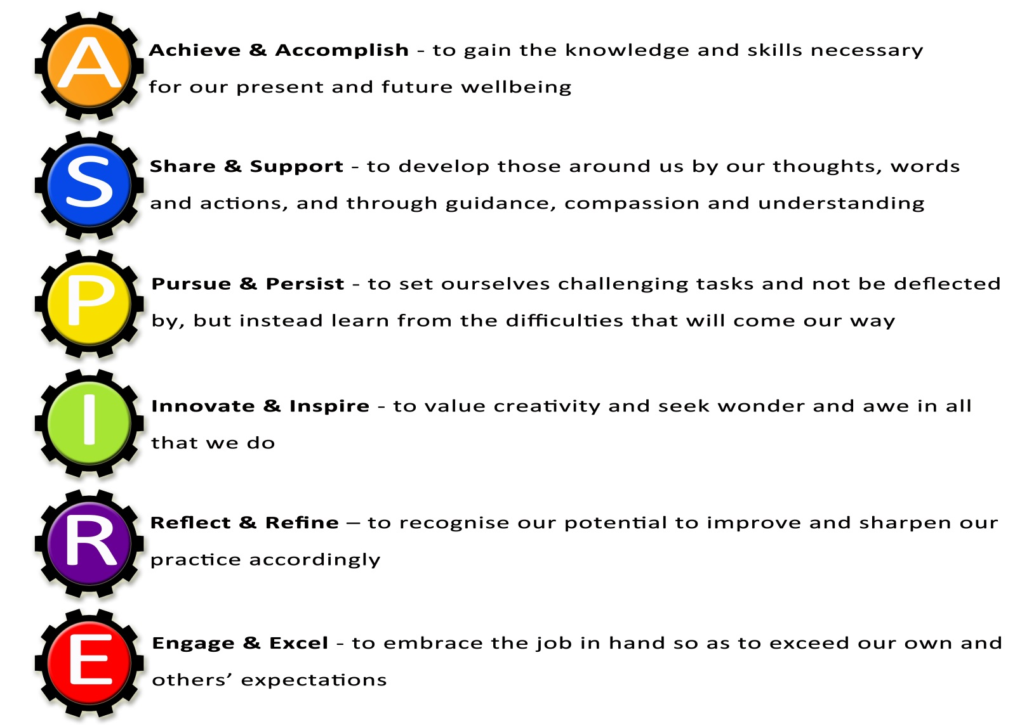



We believe that all members of our community should be aspirational, supportive of each other, persistent, innovative, reflective and willing to engage at all times.

Our aspirational values will ensure that everyone in our community is committed to success for all.

Staff Stories
  Mr Carrington, Assistant Head | Redden Court recognises and rewards hard work, enthusiasm and commitment to success. They have given me the opportunity to progress from an NQT to a Head of Faculty and now my current role as an Assistant Head within five years. I have been encouraged to introduce new technology to the school and work on a number of interesting projects. The staff and students are a pleasure to work with and our team ethic is impacting positively on our results and achievement. The school's progress in recent years has been phenomenal and there are exciting times ahead as we lead the Multi-Academy Trust to support other schools and continue to expand our own vision and ethos.
  Miss Todd, SFAET Leading Practitioner of Maths | Redden Court is a wonderful school and has supported me over the years with each stage of my professional progression. I started my training here as GTP in 2007, became leader of the house system, second in Maths and then Head of Faculty in January 2014. More recently, I have gained Lead Practitioner accreditation and when I returned to work after having my son, I was promoted to Lead Practitioner for Maths across the Success for All Educational Trust. I have been given huge opportunities and been supported each step of the way.  Redden Court is a wonderful teaching environment, with excellent resources and students who make you love the job! If you are a good teacher, with great ambition and enthusiasm you will be supported and encouraged to go on and achieve fantastic things in your career at Redden Court.
  Miss Morris, PA to Executive Head Teacher | I started as PA to the Head Teacher of Redden Court School over 10 years ago. Since then I have been promoted to PA to the Executive Head Teacher of the Success for All Educational Trust and line manage the reception area of Redden Court School.  During my time here I have helped the school achieve the Gold TFL Stars Award, help plan and organise school trips and assisted colleagues in achieving Thinking Schools Accreditation.  I have always felt supported, empowered and challenged in my role and am considered a valuable member of the school team.

  Mr Pendred, Head of Technology Faculty | I arrived at Redden Court School as an NQT, and at the time I never thought I would progress as quickly as I have. This is a school that really recognise and reward hard-work. From the very start I had the responsibility of being a subject leader in Product Design, then after only two years I progressed to Head of Department in Design and Technology, and in my fifth year at the school I was made Head of the Technology Faculty. I have had a key involvement in much of the school signage and have had opportunities to run school trips and lead a STEM club. This is an ambitious and supportive school full of great staff, and in my opinion there is no better place to pursue a career in teaching.
  Mr Barrett, Business Manager | I joined Redden Court in 2012 shortly after the school converted to Academy Status in January 2012. From that time I have learned something new every day. Little did I know the range of experiences I would have within the school. I have enjoyed every single day I have worked in the school and am extremely proud of the outcomes the students achieve and the part that I play in that. We are about to encounter an exciting time at the school with the formation of the Multi Academy Trust and building works through the Priority Schools Building Programme that will enhance the quality of provision for our students.  Redden Court is a school where I want to come to work with enthusiasm each day and I am empowered by an amazing leadership team.
  Mr Sims, Learning for Behaviour Mentor | I joined Redden Court School as a Learning Facilitator in 2016. I was immediately impressed (and inspired) by the dedication of the staff and the attitudes the students had towards learning. It is clearly evident that the school acknowledges the all round importance of the students wellbeing. I quickly became involved in the Futsal team and have managed them in competitions at the Copperbox in London. I also co-founded the Sports for Confidence team which has participated in various tournaments and competitions around the Greater London area. Redden Court School has afforded me the opportunity to advance in my career. As a result of that I have become the schools Learning for Behaviour Mentor. It is a privilege to be part of a team that truly reflects its ethos of "Success for All".

