
Behaviour and Learning Mentor
Information Pack

Dear Candidate,

Thank you for taking the time to consider joining the talented staff team here at Redden Court School and The Success for All Educational Trust. I am very proud to be the Headteacher of Redden Court, a school that is committed to the success of all students in our care.

Notable Achievements in recent years:
- In 2020 we were awarded the SSAT award for exceptional outcomes for our SEND Students
- We have recently been re-accredited as a Thinking School by the CEDU at the University of Exeter
- In 2019 we were awarded the ‘Quality in Careers’ standard for our work in this area
- The school received 2 awards from SSAT for the Progress and Attainment of students in 2016 and 2 awards in the same categories for 2017
- In the Havering Learning Partnership Awards 2019 we received the award for Wellbeing and in 2018 we received awards for Best Progress in the “Open” Subjects and an Enrichment Award for Most Innovative Technology Project. In 2017 we received awards for Best Progress Overall, Best Progress Made by Disadvantaged Students, Best Progress Made by More Able Students, Best Progress for “Open” Subjects, Best Progress in Mathematics, Best Progress in Humanities, Most Improved Attainment in the EBacc 2016
- In 2016, Ofsted recognised the progress made by the school and the fact that we have created an inclusive community where we focus on working with families to raise aspirations

We pride ourselves on being a fully comprehensive school placed at the heart of the community. We want all of our students to be happy, ambitious and to achieve results that reflect their true potential.

Our school has served the local community of Harold Wood for many years, providing a high quality education to the students of this area.

Our vision is focused on a ‘Commitment to Success for All’ and high levels of aspiration for every member of our community. The school is forward thinking and progressive. We seek to achieve the very best for all of our students through the use of a rich variety of educational approaches. We have caring staff who are dedicated to ensuring the students are successful in every aspect of their learning.

Redden Court is the founding school in the Success for All Educational Trust and is recognised as one of the highest performing mixed comprehensive schools in Havering. The SFAET will expand over the next few years to incorporate both local Secondary and Primary Schools and currently includes 3 Secondary Schools.

We are an accredited ‘Thinking School’ and have very close links with the Cognitive Education Development Unit at the University of Exeter. Metacognition and the development of thinking skills is at the heart of our teaching and learning in the school as we believe it plays an important part in developing resilient and independent learners.

We also have very strong links with the Havering Teacher Training Programme, we are a senior partner in the Empower Teaching Alliance and we are recognised as a Leading Edge School by the SSAT. The school has also been accredited with Investors in People (Silver), Healthy Schools (Gold), The International School Award, The Safeguarding Standard, Gold Travel Ambassadors Award and is a Fairtrade School.

We are a growing community Trust with inclusion at the heart of our ethos and require leaders who will bring this vision to life.

These are exciting times for Redden Court School with so much change and challenge in the future.

Perceptions play a major part in your decision when choosing the right school for you to lead and build a successful career. We strongly urge you to come and visit the school prior to application.


Mr Anthony Henry
Headteacher of Redden Court School

Behaviour for Learning Mentor September start

We have a position vacant for a Behaviour for Learning mentor to commence in September 2020
Pay Scale 5 salary £8,173 to £8,623 (Actual salary for 14 hours per week.) term time only (39 weeks).
Part time, 2 days per week.
14 hours, 8.30am to 4.00pm with 30 minutes lunch.

Redden Court School is an oversubscribed, successful converter Academy which has served the local community of Harold Wood for many years, providing a high quality education for the students of this area.

Our school motto is ‘Committed to Success for All’ and we seek to achieve the very best for our students through a rich variety of educational approaches of technology.

We wish to appoint a Behaviour for Learning Mentor to support our young people overcome behavioural barriers to their learning in order for them to achieve their full potential. The specific role here will be to work with our CLA students. As a school, we are very inclusive and will have a total of 18 CLAs from September. This is far beyond the average of Secondary School. In this post you will work alongside another Learning Mentor who is full time and works across the wider school body.

We are looking for someone who has a positive approach, resilient and can deal with students which may be vulnerable. The successful candidate must have an approachable manner and recent experience of working with young people would be desirable.

The title Behaviour for Learning Mentor highlights the need for students to become independent learners with support and strategies to overcome behavioural issues where appropriate.

The school is committed to safeguarding and promoting the welfare of children and young people and expects all staff to share in this commitment.

Supporting the needs of children looked after & adopted, along with other vulnerable children.

For details on how to apply, please visit our website: https://www.reddencourtcloud.co.uk/about-redden-court/work-with-us

Unfortunately we cannot welcome visits to the school from potential applicants in the immediate future due to the Covid pandemic. However, please feel free to contact Mr K Ward (Assistant Head) on kward@reddencourtcloud.co.uk to arrange to have an informal conversation.

Closing date: Wednesday 24th June 2020, closing at 12.00pm

Interviews: Will take place at some point in July. The exact date will be dependent on government announcements. We will endeavour to give successful candidates as much notice as possible so that they can make arrangements to attend.

Redden Court School is a member of the Success for All Educational Trust.
Cotswold Road, Harold Wood, Romford, Essex, RM3 0TS
Tel: 01708 342293 Fax: 01708 386550

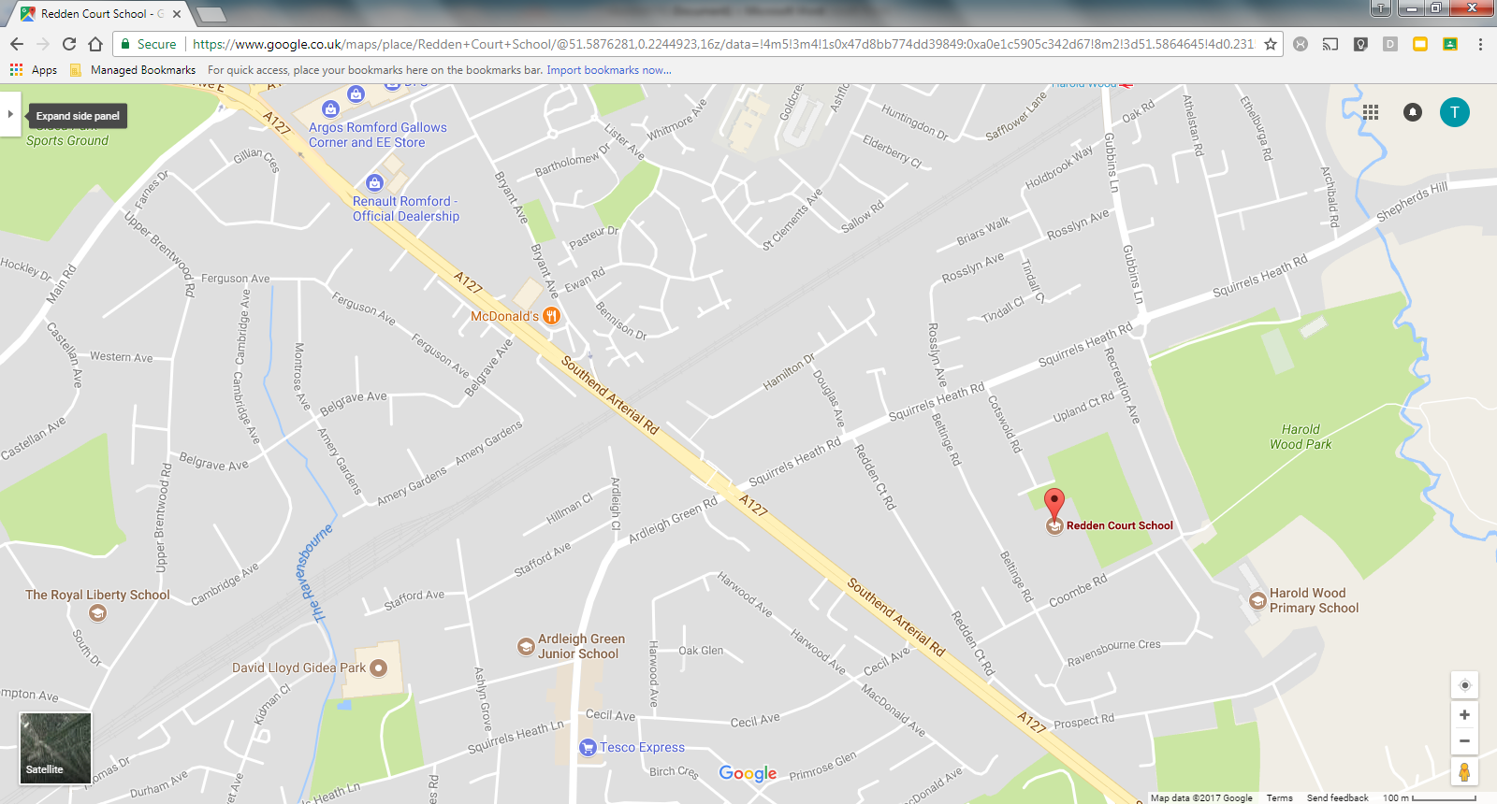

Job Profile

Behaviour for Learning Mentor

Job Purpose: To provide a complementary service to existing teachers and pastoral staff in school, addressing the needs of children who need help to overcome barriers to learning both inside and outside the school, in order to achieve their full potential. The main focus of the role is delivering skills that support students with specific behavioural issues.

Key responsibilities:

● To promote the speedy and effective transfer of pupil information at all stages of transition (from primary to secondary, from Key Stage 3 to 4, from Key Stage 4 to 5).

● To identify those children who would benefit most from a Behaviour for Learning Mentor and, working with others, draw up and implement an action plan for each child who needs particular support.

● To develop a 1:1 mentoring relationship with children needing particular support where necessary aimed at achieving the goals defined in the action plan.

● To work with groups of young people identified as not fulfilling their potential to achieve their goals.

● To maintain regular contact with families/carers of children in need of extra support, to keep them informed of the child's needs and progress, and to secure positive family support and involvement.

● Supporting the needs of children looked after & adopted, along with other vulnerable children.

● To complete home visits where necessary and record all contact with students and parents on the school’s monitoring system.

● To liaise with appropriate outside agencies such as the school nurse, EWO, Educational psychologist, CAMHS, social care etc.

● To model a professional approach in all interaction with all stakeholders across the school and speaking with students and staff with respect.

● Being involved in meetings with students, parents and other stakeholders. This may include the planning and facilitation of meetings, making contributions, taking minutes or organising hospitality.

● To contribute to child welfare and protection utilising the EHA and MARF.

● To contribute to the maintenance of records and information systems both computerised and manual with due regard for data protection and confidentiality.

● To work closely with Heads of Year on targeting efforts on those at risk of underachieving who are not already receiving effective intervention.

● To work closely with the SENDCO to ensure that the needs of children with special education needs are met.

● To participate, with other staff, in the comprehensive assessment of children and young people to identify and address barriers to learning.

● To have full knowledge and appreciation of the range of extended services that could be drawn upon to provide extra support for pupils.

● To facilitate the sharing of information between school staff and partner agencies.

● To network with other members of the pastoral team and share best practice, knowledge and information.

● To comply with all relevant legislation and school policies and procedures.

● To undertake additional duties as required by the Head Teacher commensurate with the grading and nature of the post.

Kane Ward
Assistant Head of Pastoral
Tammi Tilson
Pastoral Adminsitrator

Vacancy
Head of Year 8
Venessa Barclay
Head of Year 7
Nina Stiffel
Head of Year 10
Debbie Bennett
Head of Year 9
Mohammod Hoque
Head of Year 11

Google Education

Google Education is an exciting and innovative way of learning, introducing easy tools to engage students whenever, wherever on any device!

In summer 2012, Redden Court School adopted G Suite for Education, the free web-based communication and collaboration suite available to education establishments.

With products including Gmail, Google Calendar, Google Drive, Google Sites and Google Classroom, Redden Court School recognised the potential it would bring to classroom learning, knowledge sharing across the academies, improvements in administrative efficiency and providing access from home for all.

This enables all our students and staff to have access to the most up-to–date technology. Our academies have also rolled out many class sets of Google Chromebooks, affordable browser-based laptops that provide quick, simple access to the web!



Professional Learning Programme

It is an expectation that ALL full time staff complete 15 hours of CPD throughout the year.

These hours equate to 3 Staff Development Days when staff do not have to attend school.

9 hours are compulsory directed time i.e. Twilights and Working Parties. The remaining 6 hours can be personalised/independent e.g. collaboration with MAT partners, webinars, Exam board training, Exam board marking etc. Staff who lead a session can have double the time towards their personal hours (due to planning and preparation time needed).

You will be expected to complete a proforma as evidence of independent CPD for your remaining 6 hours

Please note, in addition to the 15 hours stated, all staff may be expected to attend additional compulsory training as deemed necessary by SLT.

EXTRA-CURRICULAR TIMETABLE
There is a multitude of extra-curricular opportunities at Redden Court and we encourage all students to attend clubs weekly and be involved in what’s on offer. Enrichment is an important part of school life and essential to the development of individual character and cultural capital.
The Extra-Curricular Timetable outlines what’s available both before and after school and at lunchtimes.

WEEKS A AND B | MONDAY | TUESDAY | WEDNESDAY | THURSDAY | FRIDAY
BEFORE  SCHOOL | THE AM NEWS CLUB | THE AM NEWS CLUB | THE AM ANEWS CLUB | THE AM NEWS CLUB | THE AM NEWS CLUB
BEFORE  SCHOOL | FUTSAL - WEEK A & B ROTATION | INDOOR ATHLETICS | Y10 FOOTBALL | Y9 FOOTBALL | ALL YEARS - GIRLS NETBALL
BEFORE  SCHOOL |  |  | Y7 & 8 GIRLS FOOTBALL | Y8 FOOTBALL | Y7 RUGBY
BEFORE  SCHOOL |  |  | SPORTS ACADEMY |  | LATIN CLUB
LUNCHTIME | MATHS PUZZLE / CHESS | DANCE | PRINTMAKING WORKSHOPS | FIIIT CLUB | POLITICS CLUB
LUNCHTIME | Y9 TABLE TENNIS | MAD SCIENTISTS | CREATIVE WRITING | Y7 TABLE TENNIS | MUSIC CLUB
LUNCHTIME | WORLD CHALLENGE | DEBATE CLUB | STUDENT NEWSLETTER | WORLD CULTURE CLUB | TEXTILES CLUB
LUNCHTIME | DIGITAL LEADERS CLUB | LITERACY QUOTES | Y10 & 11 TABLE TENNIS | HISTORY ART CLUB | GCSE TABLE TENNIS
LUNCHTIME |  | Y8 TABLE TENNIS | CHALLENGE FRENCH | GEOGRAPHY CLUB | ANTI BULLYING CLUB
LUNCHTIME |  | DUKE OF EDINBURGH |  | KS3 DRAMA CLUB
LUNCHTIME |  |  |  | JLT MEETINGS
AFTER  SCHOOL | Y7 NETBALL | ART CLUB | GYMNASTICS | BOCCIA | Y9 RUGBY
AFTER  SCHOOL | Y9 & 10 GIRLS FOOTBALL | CREATIVE WRITING | ARTS AND CRAFTS | GIRLS WHO CODE | YEAR 10 RUGBY
AFTER  SCHOOL | Y7 BOYS RUGBY - INVITE PRACTISE | KS4 GIRLS NETBALL | THE CREST AWARD | SPANISH CLUB | Y8 GIRLS NETBALL
AFTER  SCHOOL |  |  | MUSICAL THEATRE
AFTER  SCHOOL |  |  | STEM CLUB

Results 2019

Results 2019 | Redden Court School | National Averages
Progress 8 | TBC | 0
Attainment 8 | 49.23 | 44.2 | +5.03
Basics Eng & Ma (strong) | 52.05% | 43% | +9.05%
Basics Eng & Ma (standard) | 72.60% | 61% | +11.06%
Ebacc (strong) | 21.23% | 16% | +5.23%
Ebacc (standard) | 45.21% | 24% | +21.21%

Staff Benefits

Career Development:

- Apprenticeships
- Support towards achieving further qualifications
- Leadership programmes
- Progression opportunities
- Teacher Training Programme

Financial:

- Pension – teaching staff access Teacher Pension Scheme and Associate Staff access Local Government Pension Scheme
- All teaching staff are allocated a Chromebook

Health and Wellbeing:

- Schools Advisory Service offering:
  - Access 24 hours a day to a GP Helpline where you can have a telephone consultation for you and close relatives.
  - Access to Physiotherapy
  - Access to a counselling service
  - Free 12 week Weight Management Programme
  - Support for stress management
  - Lifestyle Screening
  - Relationship Counselling
  - Long Term Condition support - Support for you and family members where you or a member of your family is suffering from a long term condition such as cancer, Multiple Sclerosis or Motor Neurones Disease. This list is not exhaustive.
  - Private Medical Service
  - Stress Counselling

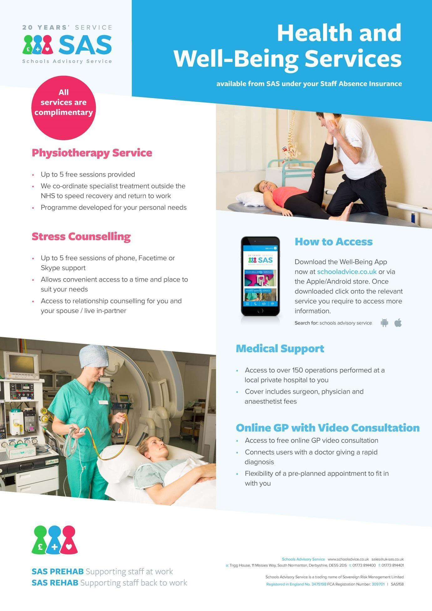

VALUES AND ETHOS STATEMENT

At Redden Court, our Mission Statement has been formulated as a result of the collective input of all stakeholders in our community, parents, staff, governors and particularly our students. We have chosen to express our mission through our ASPIRE logo:



and our ASPIRE ethos:


Achieve and Accomplish

“At Redden Court we support and challenge each other to achieve and accomplish”. Connor H
“I want to be successful in everything I do. For me it is not enough to just become okay at something. I like to know that I have not only achieved but that I have become accomplished.” Lucy E





Share and Support

“Sharing is something I value – for me, sharing is caring. I value other people’s opinion as they help me to build my own ideas.” Olivia W
“From as soon as I started at Redden Court it was clear that everyone was happy to listen to my ideas and give me help when I needed it.” Daniel O

Pursue and Persist

“Being knocked down doesn’t mean you just give up, it means you get back up and try even harder. It’s the world telling you to just give that little bit more.” Scarlet J
“When I have my eye on something, whether it’s an ‘A’ in a science test, or a game winning try in rugby, I practise, practise, practise. If I keep improving, eventually I will reach my goal.” Luyi G

Innovate and Inspire

“At Redden Court I am inspired to innovate and to think outside the box. I am encouraged to expand my knowledge and to ask myself, “what if” and “why”. Megan C
“I think it is as important to inspire as it is to find inspiration. I am a reading mentor and hope to inspire those that I support.” Thomas B


Reflect and Refine

“In lessons, we are encouraged to think deeply about our work, recognise what we have done well and see how we can develop it. Sometimes it is hard, to be honest, but I know it will help me to succeed.” Katie C
“Reflecting and refining means to a lot – I’m not scared to learn from my mistakes. I am able to go back to my previous work and pick out the points I can improve.” Laura Y


Engage and Excel

“I want to surpass the expectations others have of me and know that I will need to work hard at everything - even the little things – that I need to do.” Kim D
“I have high expectations for myself, but I know that success doesn’t come without hard work.” Jed R
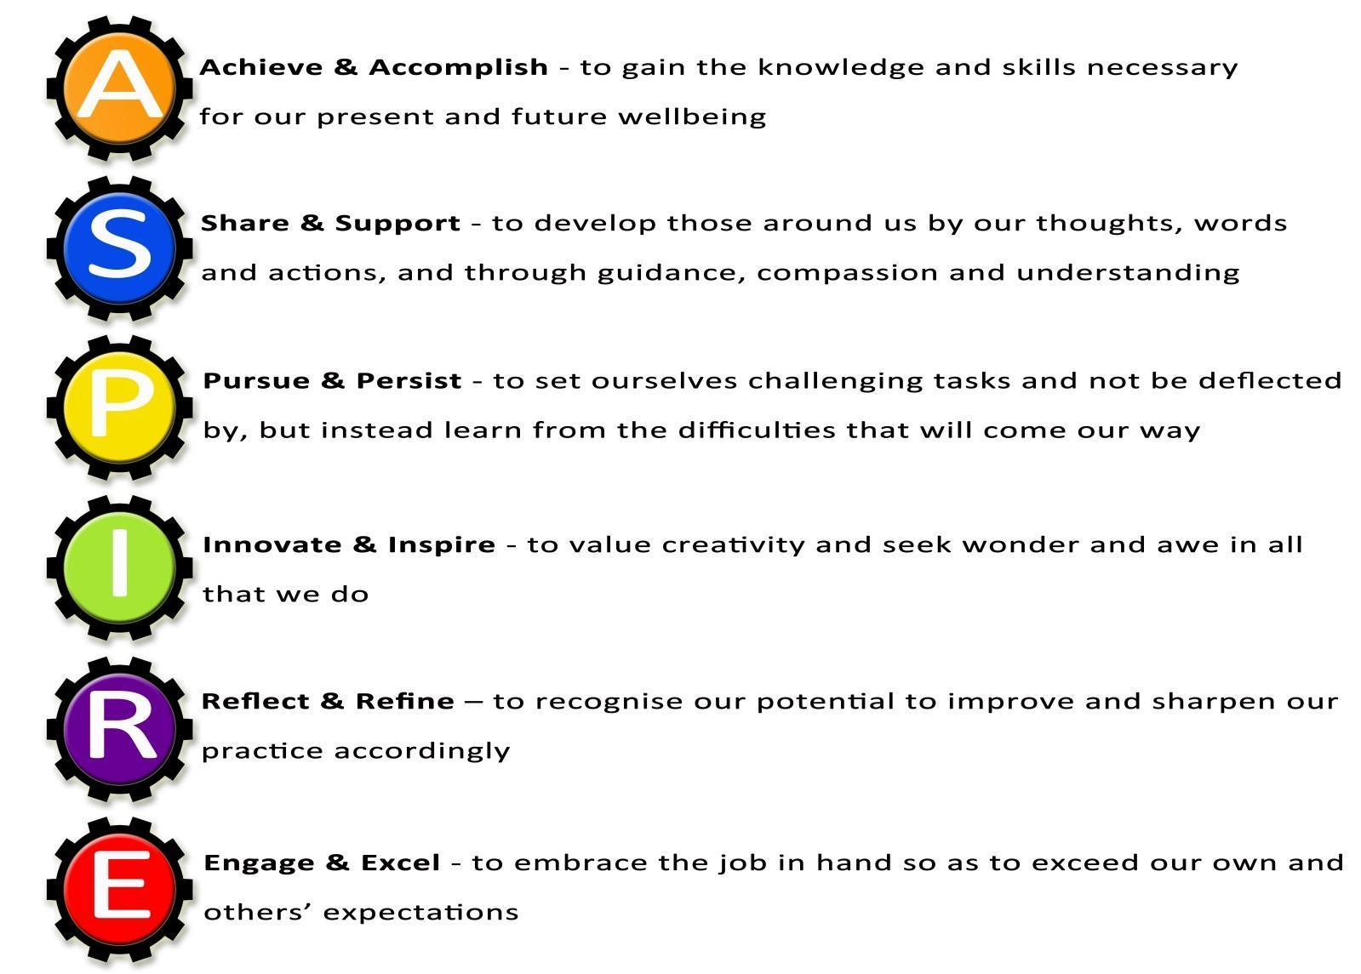



We believe that all members of our community should be aspirational, supportive of each other, persistent, innovative, reflective and willing to engage at all times.

Our aspirational values will ensure that everyone in our community is committed to success for all.

Staff Stories
  Mr Carrington, Assistant Head | Redden Court recognises and rewards hard work, enthusiasm and commitment to success. They have given me the opportunity to progress from an NQT to a Head of Faculty and now my current role as an Assistant Head within five years. I have been encouraged to introduce new technology to the school and work on a number of interesting projects. The staff and students are a pleasure to work with and our team ethic is impacting positively on our results and achievement. The school's progress in recent years has been phenomenal and there are exciting times ahead as we lead the Multi-Academy Trust to support other schools and continue to expand our own vision and ethos.
  Miss Todd, SFAET Leading Practitioner of Maths | Redden Court is a wonderful school and has supported me over the years with each stage of my professional progression. I started my training here as GTP in 2007, became leader of the house system, second in Maths and then Head of Faculty in January 2014. More recently, I have gained Lead Practitioner accreditation and when I returned to work after having my son, I was promoted to Lead Practitioner for Maths across the Success for All Educational Trust. I have been given huge opportunities and been supported each step of the way.  Redden Court is a wonderful teaching environment, with excellent resources and students who make you love the job! If you are a good teacher, with great ambition and enthusiasm you will be supported and encouraged to go on and achieve fantastic things in your career at Redden Court.
  Miss Morris, PA to Executive Head Teacher | I started as PA to the Head Teacher of Redden Court School over 10 years ago. Since then I have been promoted to PA to the Executive Head Teacher of the Success for All Educational Trust and line manage the reception area of Redden Court School.  During my time here I have helped the school achieve the Gold TFL Stars Award, help plan and organise school trips and assisted colleagues in achieving Thinking Schools Accreditation.  I have always felt supported, empowered and challenged in my role and am considered a valuable member of the school team.

  Mr Pendred, Head of Technology Faculty | I arrived at Redden Court School as an NQT, and at the time I never thought I would progress as quickly as I have. This is a school that really recognise and reward hard-work. From the very start I had the responsibility of being a subject leader in Product Design, then after only two years I progressed to Head of Department in Design and Technology, and in my fifth year at the school I was made Head of the Technology Faculty. I have had a key involvement in much of the school signage and have had opportunities to run school trips and lead a STEM club. This is an ambitious and supportive school full of great staff, and in my opinion there is no better place to pursue a career in teaching.
  Mr Barrett, Business Manager | I joined Redden Court in 2012 shortly after the school converted to Academy Status in January 2012. From that time I have learned something new every day. Little did I know the range of experiences I would have within the school. I have enjoyed every single day I have worked in the school and am extremely proud of the outcomes the students achieve and the part that I play in that. We are about to encounter an exciting time at the school with the formation of the Multi Academy Trust and building works through the Priority Schools Building Programme that will enhance the quality of provision for our students.  Redden Court is a school where I want to come to work with enthusiasm each day and I am empowered by an amazing leadership team.
  Mr Sims, Learning for Behaviour Mentor | I joined Redden Court School as a Learning Facilitator in 2016. I was immediately impressed (and inspired) by the dedication of the staff and the attitudes the students had towards learning. It is clearly evident that the school acknowledges the all round importance of the students wellbeing. I quickly became involved in the Futsal team and have managed them in competitions at the Copperbox in London. I also co-founded the Sports for Confidence team which has participated in various tournaments and competitions around the Greater London area. Redden Court School has afforded me the opportunity to advance in my career. As a result of that I have become the schools Learning for Behaviour Mentor. It is a privilege to be part of a team that truly reflects its ethos of "Success for All".

