The Royal Liberty School
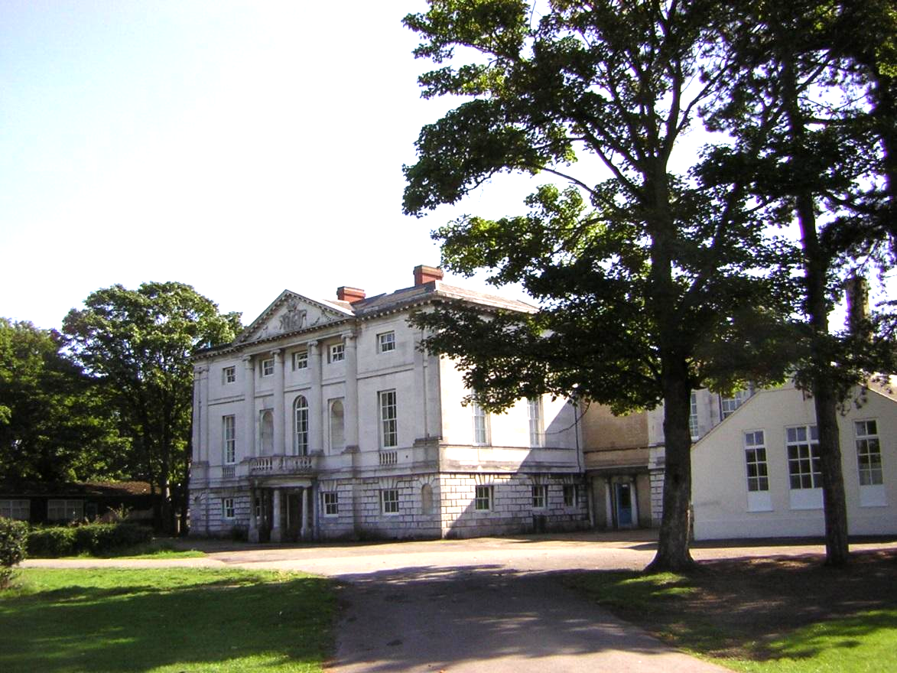
Information Pack 2021




The Royal Liberty School
"Where boys are ambitious, where boys succeed"

Head Teacher: Ms April Saunders BSc (Hons)

Last OFSTED inspection 5th February 2019: Judgement GOOD

Dear Candidate,

Thank you for taking the time to consider joining our team of staff at The Royal Liberty School part of the Success for All Educational Trust.

We share the Trust vision of ‘Commitment to Success for All’ and work hard as a team to ensure our students develop the skills that will enable them to achieve the very best at every stage of their life.

Our school has a unique character centered around the positive and respectful relationships between all stakeholders. If you were to ask a parent why they chose Royal Liberty School for their son, they would tell you we succeed in combining academic excellence with a range of opportunities beyond the classroom and provide excellent pastoral care. Our recent Ofsted inspection report states ‘Pupils are well behaved, respectful and courteous’ and ‘parents value the sense of community, which is palpable throughout the school’.

Our students are amazing and we provide many opportunities for them to represent us; for example, our Science and MFL Ambassadors who tour local primary schools and teach younger students and our Elite Sport Programme students who run the borough primary Tri-Group Tournament.

We are committed to improving outcomes for all students and have a focus on high quality teaching and learning to ensure the best possible progress. Our Partnership with Redden Court School & Sanders Draper School has afforded us fantastic opportunities to collaborate and share best practice. As a school we continuously strive for improvement and this is reflected in our improving results in all areas. This was recognised in our recent inspection “Teachers’ strong subject knowledge is also used well when correcting pupils’ misunderstandings”.

We use every opportunity to develop staff at all levels, we have a comprehensive CPD Programme and support staff at all levels to develop and experience opportunities to progress their careers. We were immensely proud that two of our teachers achieved national recognition through Pearsons Silver Teaching Awards in 2020.

Staff well-being is very important to us and we buy into SAS Health and Well-Being Services which offers a range of services for all staff in the school.

Visitors to our school are always impressed by the calm, purposeful and friendly atmosphere. Please come and visit us to see for yourself and meet some of our amazing students and staff. Please also look at our website to see some of the fantastic work we do.
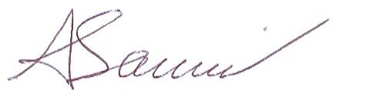

April Saunders
Headteacher

Our Vision
To be growth mindset community where ambition, hard work and resilience makes
success for all a reality.


Our Values

We believe boys are more successful when they learn together. They thrive in an environment in which they
are allowed to develop confidence, individuality and independence.

Boys at Royal Liberty succeed because they are inspired to learn, challenged to exceed expectations and encouraged to persist in the face of adversity.

All our staff work together to overcome any barriers to success. We are ambitious for our students and this empowers our students to believe that with hard work, persistence and determination they can achieve their goals.

Our students learn in an environment firmly rooted in an ethos of respect, understanding and empathy for others. Our students today are learning to be the successful young men of the future.


SCHOOL DESCRIPTION

In 2017 we joined the Success for All Educational Multi Academy Trust. We are making extensive use of our partnership with Redden Court School and since September 2018, Sanders Draper School to continually raise standards of teaching and learning and student outcomes.

We are using these links to drive further improvements in all aspects of learning across the Trust.

From September 2018 we expanded by 1 form of entry (to 5 forms) to meet the increasing demand for places. We have received funding for an extensive refurbishment of our buildings and an additional sports hall, food technology room and science laboratory. In addition to this the school is undergoing a full refurbishment. We move back into our updated facilities in September 2021, in time to celebrate the school’s 100 year anniversary.

We are a small school and have a strong sense of community. Boys are proud to be a part of the school and this reflected on their excellent behaviour and eagerness to take on roles of responsibility and to represent us in the local community.

Staff and students have excellent relationships based on mutual respect. All members of the school community are ambitious to succeed. Students feel supported to achieve the very best they can and are encouraged to develop the skills and qualities they need to be successful every stage of their life.

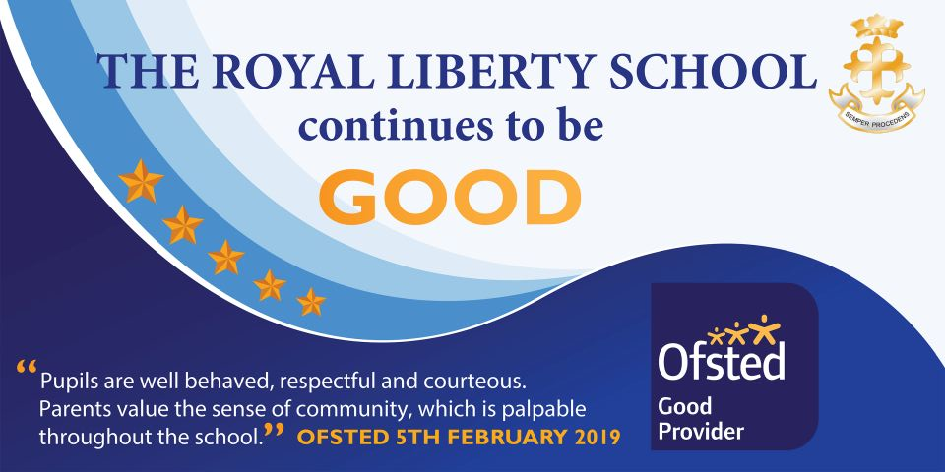


What people say about us

“In lesson students were learning effectively as the climate for learning was strong”
“There were good relationships between teachers and students and as a result students enjoy their learning”
(Dame Joan McVittie (March 2018)

“The school has a great many strengths not least of which are the very good attitudes and behaviour of the students”
“Students are well-mannered and polite around the school”
(SSAT Peer Review – January 2017)

“I have made new friends easily and I feel part of this great school”
“It is a lot bigger than primary and I did get lost but everyone helped. It is an amazing school and I love it here”
(Year 7 – 2017)

“I am happy teaching at Royal Liberty School as there is a strong behavior policy in place and excellent support to improve teaching and learning”.

“The senior leadership team presence is strong across the school”. SLT are supportive
(Staff 2018)

“The Headteacher and Senior Leadership Team have a comprehensive understanding of the school’s strengths and weaknesses’.
(Ofsted February 2019)

“Middle Leaders are effective and contributed well to raising standards of the Teaching & Learning in their areas”.
(Ofsted February 2019)

“Pupils are well behaved, respectful and courteous”.
(Ofsted February 2019)

“Parents value the sense of community, which is palpable throughout the school”.
(Ofsted February 2019)

GCSE Results 2020
HEADLINE FIGURES
Attainment 8 | Standard Pass in English and Maths | Strong Pass in English and Maths
55.64 | 80% | 59.81%

Qualifications | 9-4 | 9-5
English (Best of) | 88.68% | 67.92%
English Language | 85.85% | 66.04%
English Literature | 82.08% | 64.15%
Maths | 85.05% | 68.22%
French | 100% | 100%
German | 100% | 66.67%
Russian | 100% | 100%
Statistics | 100% | 100%
Biology | 98.08% | 84.62%
Chemistry | 98.08% | 84.62%
Physics | 98.08% | 92.31%
Computer Science | 97.14% | 88.57%
GCSE PE | 96.55% | 86.21%
Music | 90.91% | 90.91%
Hospitality and Catering | 88.89% | 72.22%
Business Studies | 87.80% | 78.05%
Design and Technology | 87.18% | 76.92%
Spanish | 81.82% | 45.45%
History | 80.39% | 64.71%
Geography | 79.31% | 68.97%
V Cert Health and Fitness | 70% | 20%
Fine Art | 69.57% | 47.83%
Film Studies | 68.75% | 37.50%
Combined Science | 65.45% | 45.45%
Drama | 46.15% | 30.77%
* Based on internal data as there is no national progress 8 data this year
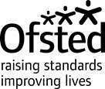
Ofsted
Piccadilly Gate
Store Street
Manchester T 0300 123 4234
M1 2WD www.gov.uk/ofsted

28 February 2019

Ms April Saunders
Headteacher
The Royal Liberty School
Upper Brentwood Road
Romford
Essex
RM2 6HJ

Dear Ms Saunders

Short inspection of The Royal Liberty School
Following my visit to the school on 5 February 2019 with Ian Morris, Ofsted
Inspector, I write on behalf of Her Majesty’s Chief Inspector of Education, Children’s Services and Skills to report the inspection findings. The visit was the first short inspection carried out since your predecessor school was judged to be good in May 2013.

This school continues to be good.

The leadership team has maintained the good quality of education in the school since the last inspection.

You and the senior leadership team have a comprehensive understanding of the school’s strengths and weaknesses. You have put in place systems that hold middle leaders to account, for example regular meetings which focus on key areas for improvement. This consistent approach is also visible in classrooms across the school, for instance in the system students use to review their work. An additional emphasis is placed on ensuring that disadvantaged pupils do well. This is in response to the recent underperformance of this group in GCSE examinations.

Middle leaders are effective and contribute well to raising standards of teaching and learning in their areas. Senior and middle leaders meet regularly to check that pupils are learning as well as they should. Governors know the school through regular visits, their involvement in learning walks and reviews of pupils’ performance with leaders. They draw on their experience and training to provide timely and effective support and challenge to the school’s leaders. Additional support from the trust, for example through sharing lead practitioners for English and mathematics, enables leaders to make further improvements in teaching and learning.

Most parents and carers who responded to Ofsted’s online survey, Parent View, were very supportive of the school. Several parents of children with special educational needs and/or disabilities (SEND) praised the school’s individualised support and care.
Pupils are well behaved, respectful and courteous. They appreciate the guidance and challenge they receive in lessons and the encouragement from their teachers. Parents value the sense of community, which is palpable throughout the school.

Safeguarding is effective.
Leaders and governors have ensured that all safeguarding arrangements are fit for purpose. Clear and rigorous systems for staff checks and pupil records are in place. These are detailed, are of a high quality and are kept meticulously updated.

Governors have received extensive training, and a clear plan is in place to ensure that this crucial area of leadership is never left unattended. Leaders at all levels are fully aware of safeguarding risks that are prevalent in the local area, such as gang activity and knife crime. These inform training for staff and pupils. Regular tests check adults’ understanding of safeguarding issues.

The school responds swiftly when concerns arise. Leaders and other staff work in partnership with external agencies to safeguard pupils’ welfare. Pupils said that they feel safe in school and in the local area. They spoke positively about the safer internet days and the anti-bullying steering group led by a middle leader. These activities complement the school’s new behaviour policy, which sets clear expectations in and out of the classroom. Staff provide a visible but unobtrusive presence around the school when pupils are moving between lessons.

The school has effective systems in place to ensure the safety of pupils, especially the most vulnerable, when they are not on site. An electronic attendance register is used to make sure that any pupils educated off site are accounted for on a daily basis. The school uses resources from the trust when excluding pupils who are at risk to continue to ensure their safety.

Inspection findings
- At the start of the inspection, we agreed to focus on the progress and attainment of disadvantaged pupils. GCSE results from previous years indicate that these pupils did not make as much progress as other pupils nationally.
- Disadvantaged pupils typically account for around one third of the school’s population. Leaders’ use of additional funding to support these pupils is well planned. Leaders regularly visit classrooms to monitor its impact on teaching and learning.
- Teachers have good awareness of pupils who are disadvantaged and are therefore able to give them priority when necessary. Inspectors spoke to disadvantaged pupils who have been appointed as learning champions. They spoke with enthusiasm and confidence, showed pride in their work and were able to demonstrate good progress through their books.
- You have strong systems to monitor attendance and follow up where this does not meet expectations. As a result, the attendance of disadvantaged pupils, which was below national rates in 2018, has now improved. However, the rate of persistent absence for the same pupils remains greater than that of their peers.
- The second focus for the inspection was pupils’ progress and attainment in English, mathematics, science and the humanities. Historically, GCSE results in these subjects showed some underperformance. However, there was an improvement in pupils’ progress in 2018.
- Leaders undertake rigorous monitoring with support from the trust and external consultants. The effectiveness of middle leaders is consistent across departments. This is as a result of regular opportunities for staff to meet and share good practice during training sessions.
- The school’s current assessment information suggests an improving trend in English, mathematics, science and the humanities. This view was supported by work seen in classes during this inspection. In Year 10 mathematics, for example, we saw teachers skilfully guiding students to apply previously learned skills in harder contexts, such as moving from calculating the area of a pyramid to that of a cone. The insistence on improving work supports pupils in preparing for assessments. One commented: ‘It really helps when we come to revise.’
- Teachers’ strong subject knowledge is also used well when correcting pupils’ misunderstandings. Work in pupils’ books shows clear progression over time. For example, in English, pupils are encouraged to draft and repeatedly revise their work before settling on a high-quality final version. Pupils talk about this work with interest and in depth. However, in history and science, inspectors saw less evidence of challenge at the highest level.

Next steps for the school
Leaders and those responsible for governance should ensure that:

- all pupils are appropriately challenged and that they receive precise guidance about how to reach the highest levels in history and science
- actions to raise the achievements and reduce the persistent absence of disadvantaged pupils are continued to narrow the differences with other pupils nationally.

I am copying this letter to the chair of the governing body, the chief executive officer of the multi-academy trust, the regional schools commissioner and the director of children’s services for Havering. This letter will be published on the Ofsted website.

Yours sincerely

Luisa Bonelli
Ofsted Inspector

Information about the inspection

Inspectors looked at a wide range of school documentation, including the school’s self-evaluation, assessment information and documents relating to safeguarding. We visited classes with senior leaders, looked at work in pupils’ books and spoke with staff and pupils. We met with school leaders, the leader with responsibility for safeguarding, the assessment manager and the pupil premium coordinator. We held meetings with the chief executive officer from the multi-academy trust. In addition, we analysed the 39 responses to Ofsted’s online survey for parents, the 38 responses to the staff questionnaire and the 55 responses to the pupil survey.

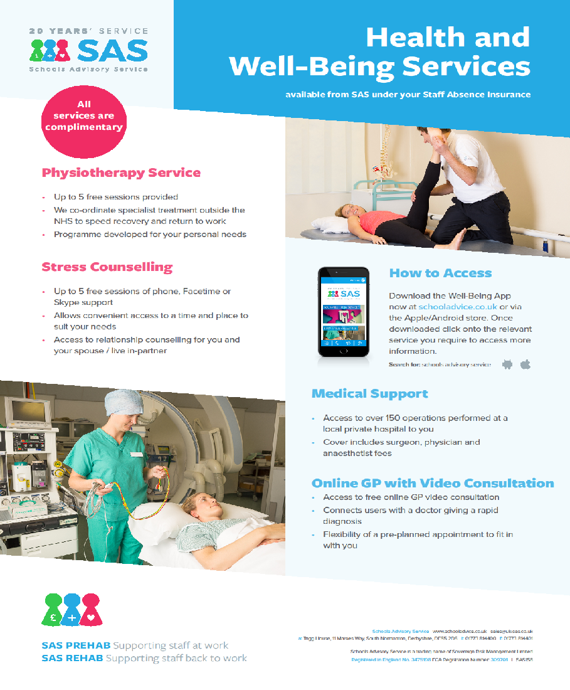

STAFF TESTIMONIALS

Brad Bowen

My journey began at the Royal Liberty School a very long time ago as a student between 2005 - 2010. I had a very enjoyable and successful five years which prepared me for further education. I then, as if that wasn't enough, returned twice for my College and University Work Placement modules in 2012 & 2014, working within the Physical Education department and gaining valuable experience. When I graduated I knew I wanted to become a teacher and after two years of cover teaching an opening within the department arose to which I applied immediately. This saw me finally return on the other side of education and as a staff member here at the Royal Liberty School. The following year allowed me to progress with the opportunity to complete my QTS qualification and I am now into my third academic year of teaching. I believe Royal Liberty was a school that allowed me to be ambitious, and achieve."

Mr B Bowen - PE teacher - 2020

Adam Higgins

I joined Royal Liberty as a trainee teacher through the Havering Teacher Training Partnership in 2016. I enjoyed working at the school so much that I have stayed ever since.

Due to the supportive environment at the school, I have managed to progress from trainee teacher to second in science with a responsibility of key stage three and our outreach programme. The school have supported my own personal development by encouraging me to take advantage of many opportunities such as presenting at the PIXL science conference, speaking at the Association of science educators national conference, writing for the Education in Chemistry magazine and becoming an author of resources for the Oxford University Press.

Royal Liberty is also a school where hard work is recognised, thanks to Royal Liberty I have been shortlisted for the Evening Standard Inspirational teacher of the year in 2019 and was also recognised at the Havering Learning Partnership awards.

The supportive nature of the school allows staff to provide an abundance of opportunities for the students which allows them to develop academically as well as allowing them to grow as people. This truly feeds through to the whole ethos of the school with it being reflected in both student and staff attitudes to learning. A large emphasis and trust are placed upon staff inside and outside of the classroom. The school allows teachers the freedom to develop extracurricular activities, this has allowed me to coordinate in-school clubs, various trips and visits, borough-wide student competitions and an extensive outreach programme to local primary schools.

Without such a supportive environment and senior leadership team, I feel that I would not have developed as a teacher in the same way in which I have. Royal Liberty is a great working environment with unique students. It is a school where you are encouraged to constantly better your practice and therefore always support the boys to succeed.

Mr A Higgins - Science Teacher - 2020
Pearsons Silver Award Winner for Outstanding New Teacher 2020
Geraldrine Agyeman
Before completing my PGCE, I knew that The Royal liberty School was the right place for me. Staff were incredibly supportive, helpful and driven to help me to obtain an outstanding grade. During this time, members in and outside my department shared their resources, expertise and knowledge of pedagogy in my subject area and guided me to exceed or in the least- meet the teaching standards. This made my training exciting as I was learning to adapt strategies to suit the different needs of pupils and at the same time form my identity as a teacher. Ultimately, I was passed my PGCE with an outstanding – owing to the resources, materials and expertise made available to me during my training. Today, as an NQT, this network of guidance and support persists with numerous training opportunities ranging from helping me to manage workload and effective marking and feedback to improving attainment in disadvantaged pupils. I am also enjoying implementing strategies I encountered during my PGCE and developing relationships with the pupils be it through playing table tennis or guided practice of challenging concepts. I am driven to contribute and challenge pupils further through a mentoring programme and engage with pupils outside the curriculum through a number of clubs such as British Sign Language and STEM. In all, The Royal Liberty School has been and continues to be exceptionally dedicated to my continuous growth as a teacher and as an individual.
Ms G Agyeman - Maths Teacher - 2020

Julie Cooper

My journey at The Royal LIberty School began in January 2003, filing and answering the phone in the office. Little did I know how much working with the students and staff at this school would inspire, challenge and motivate me to progress from working one day a week, to 3 days a week and finally full-time - from receptionist to Pastoral Support Assistant/Cover Supervisor to Head of House and to my current role as Head of Year 7 and a member of the safeguarding team.

Within each role I have been afforded the opportunities to become involved in other activities to help enrich student’s experiences of education both around learning and their wellbeing, this had included coordinating extra-curricular activities, leading on the Duke of Edinburgh school, running Jack Petchey training and intervention programmes.

Being part of the safeguarding team has allowed me to develop further; being part of a team that creates an environment where children feel safe in their surroundings, keeping up to date with policy and practice and responding to concerns. This allows us to ensure the needs of a child always comes first.

My work with the Year 7’s inspires me, from my first contact with them in their primary school setting, through to their transition to secondary school and then throughout their first year. Watching these young men gain confidence, self esteem and life skills makes my role everyday rewarding and worthwhile. A privileged position to be in.

Head of Year 7 - 2020

Jean Vincent

I started at the RLS in 2003 as an attendance officer, it was the first time I had worked in a school so did not know what to expect. Before all the new tech was introduced the role was a lot of admin tasks. As the years went on new systems was introduced involved a lot of learning and progressing into the 20th century. I am still working here after 16 years and seen a lot of changes not just within my role but the school

As an associate member of the school the staff I work within my role of an examinations/admissions officer SLT are always at hand to help and assist me in all aspect of my job. Students are always polite and hardworking. My invigilators have been working here for some years always comment on the excellent behaviour within the examination of the students.

The Royal Liberty School is a friendly school and whenever I can I recommend the school to friends and family.

Ms J Vincent - Exams Officer - 2020

K Larner

I have now been at The Royal Liberty School for over 12 years. I joined The Royal Liberty School soon after I finished my PGCE. Although the first year of teaching can be daunting I found the staff at Royal Liberty were very supportive and helped me constantly improve. As a small school you get to know all the staff and there is a strong feeling of community. There are many chances to work collaboratively and staff are very willing to help their colleagues when they can.

There have also been lots of opportunities to progress within the school. I have been able to take on several different roles during my time at Royal Liberty. I started as a history teacher and then took on the role of KS3 Curriculum Coordinator. This allowed me to work on a cross-curricular role. This then led on to the role of Literacy Coordinator and a cross-school role. Finally, I have taken on the role of SENCO within the school. I have been supported throughout my time here and been given the opportunity to attend training and gain qualifications that have been pivotal for my role, such as the National Award for SEN Coordination qualification.

Ms K Larner - History Teacher/SENDCO - 2020

Ms K Ralston

I joined Royal Liberty School as a trainee on the Havering SCITT programme. I was fortunate to have an incredibly supportive mentor, and faculty, that helped me develop my teaching practice. I have remained at the school ever since, progressing through my NQT year and then becoming the subject specialist for history. More recently I have also gained responsibility for SMSC and RE across the school. My time at Royal Liberty has offered me many opportunities, including training and mentoring, ensuring that I have continued to develop professionally. I am incredibly proud of the progress that my department has made and this is the result of the hard work, drive and aspirations of the staff and students. I have loved being a part of Royal Liberty’s success in recent years and am excited to see the school build on this.

Ms K Ralston - History Teacher - 2020
Pearsons Silver Award Winner for Outstanding Teacher 2020

Year 6 Parent Comments

‘My son is a very hardworking student who has performed exceptionally above national average throughout his primary education in all areas. He is a natural leader and participates in extracurricular activities. He will greatly benefit from academic and extracurricular activities you have on offer in your prestigious institute’.

‘I believe my son is going to achieve better and meet his potential at a single sex school. I admire the ethos and pastoral care at Royal Liberty. I am also impressed with the results and behaviour of the boys’.

‘Was very impressed with the Royal Liberty. The Head’s speech was very inspiring and I think the size of the school and the future developments will be excellent and my son would really be happy there’.

‘My son likes this school because it has a very good maths department which in the last 4 years has continued to get better and better. Also its design and technology department was very good and from year 7 it looked like the students were able to do practical work. Also with all the new work going on its sports department will only get better’.

‘Liberty has been known with good reputation, academic influence on the pupils, well disciplined pupils. I believe the school will be a great school for my son and benefit his education’.

‘WOW what a school! From attending the open evening and a visit in school hours we were impressed by everything the school has to offer. The teachers and pupils are enthusiastic and a credit to the school. We could see the school listens to the pupils and want them to have an enjoyable education with a bonus of all being catered to boys. The school has a great working partnership with parents. There are many options available to the pupils and the Science and DT rooms have so much to offer. We know my son will thrive in this school environment’.

